Resy the Fire Pigeon!!

He’s so hot right now he may as well be on fire!

So come and get your very own Resy today!

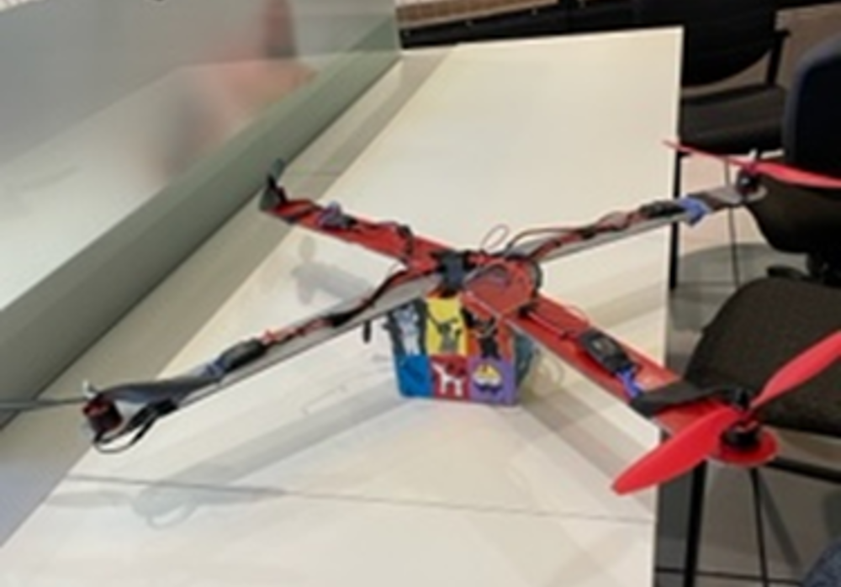

He’s a beast in the air and can handle any weather conditions! His motors are so powerful he could even sweep you off your feet! (Careful ladies!) There are so many off-brand and boring drones out there, but with Resy, you’ll have hours of fun, and with how open to suggestion he is, you could even customize him yourself! That’s right, Resy can be your very own unique design and you can finally be proud enough in yourself to forget about the disappointment you have for your children! Buy yours today and you can terrorize anyone you want!

[](file:///C:\Users\Brandon\SkyDrive\Desktop\Zach's%20Stuff\UAT%20Work\Drones\Resy's%20Backstory.html)